Keith Yao and Arav Goyal
CS4973
Phase 2
November 10th, 2025

GitHub Link: https://github.com/keithy1012/CodeSwitchProject
Processed CSV: https://github.com/keithy1012/CodeSwitchProject/blob/main/data/processed/2025-11-06/processed_dataset.csv

Data Collection Completion & Quality

After preprocessing and linguistic feature extraction, the final dataset contains:
- Total tokens: 125,048
- Distinct tokens: 3,143
- Total utterances: 6,083
- Number of Dialogues: 798
This comfortably exceeds the minimum requirement of 15,000–20,000 tokens, ensuring the dataset has sufficient linguistic diversity for both feature extraction and downstream code-switching modeling tasks.
The computed mixed-utterance rate (proportion of dialogues containing both English and Mandarin) is: 28.69%. This falls within the desired benchmark range of 20–30%, aligning well with real-world bilingual code-switching distributions observed in datasets such as ASCEND. The result suggests a balanced representation of monolingual and bilingual utterances, making the dataset suitable for studying language-switching dynamics.
All raw JSON dialogue data was successfully normalized and processed into a structured tabular format. Each record includes the following attributes:
- id: unique identifier
- utterance: one utterance / sentence spoken by a speaker
- Source: “LLM”
- generation_strategy: LLM prompting strategy used
- model_name: model variant used for generation
- dialogue_text: the full dialogue text returned from the LLM
- turn_index: unique identifier within a dialogue that represents the n-th turn of an utterance
- speaker: the speaker in the dialogue
- tokens: tokenized representation of each utterance
- pos_tags: part-of-speech tags (via spaCy and jieba for English and Mandarin POS tagging)
- Labels: a set of languages used in this dialogue
- Language: a list that shows what language every token is in
No unparsed or malformed entries were found. Each utterance was verified to have a consistent number of tokens and POS tags, confirming successful linguistic preprocessing. Additionally, a simple language detection script tagged each utterance with language indicators (zh, en), enabling downstream code-switch classification and mixed-utterance analysis.

Dataset Characterization & Analysis
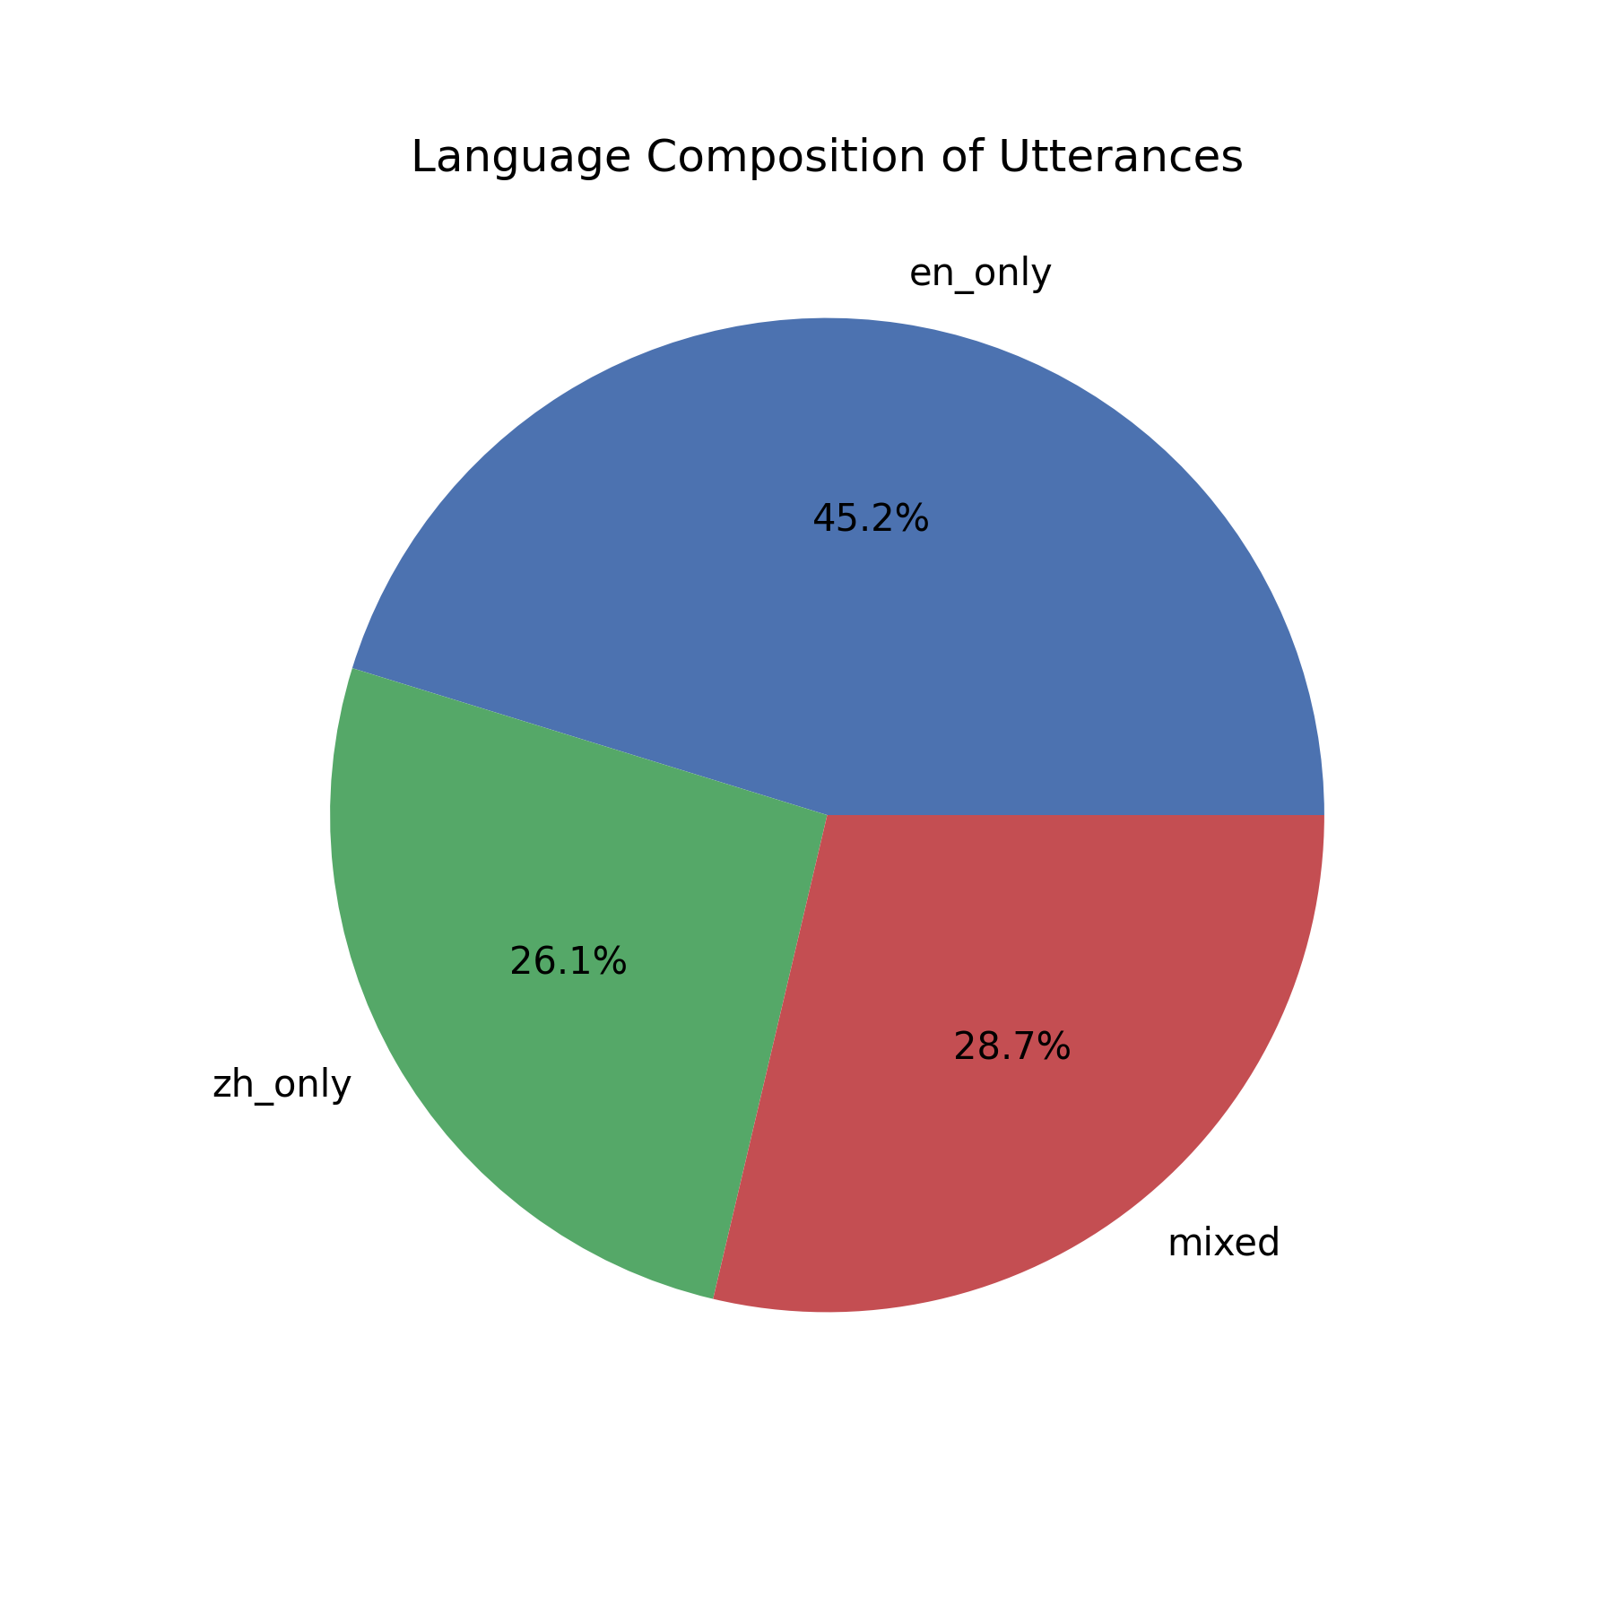
This pie chart demonstrates the composition of types of dialogues in our dataset. Around 29% of utterances are mixed, indicating that they have some form of code-switching. Around 26% of utterances are purely in Mandarin characters, and around 45% are in pure English language.
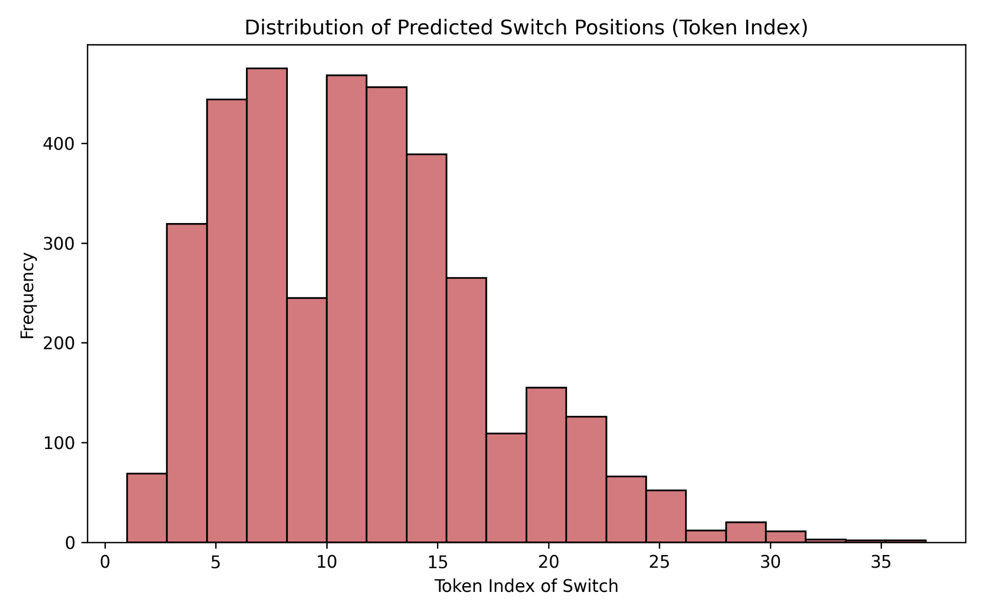
This histogram shows the position index of code-switches in our utterance. Most code switching happens early on in utterances, with the peak being at around index 5-15. After around token index 15, the frequency of switches decreases steadily. This means once a speaker commits to a language mid-sentence, they often maintain it for the rest of the utterance. The tail extending to about index 30-35 shows that late switches are possible but rare, which likely occur in long, complex sentences or multi-clause utterances. The pattern indicates that models could benefit from positional encoding (relative token position) as a feature, early tokens may carry stronger contextual cues for predicting switches, later tokens may require deeper syntactic or discourse-level context to identify rarer switch points.
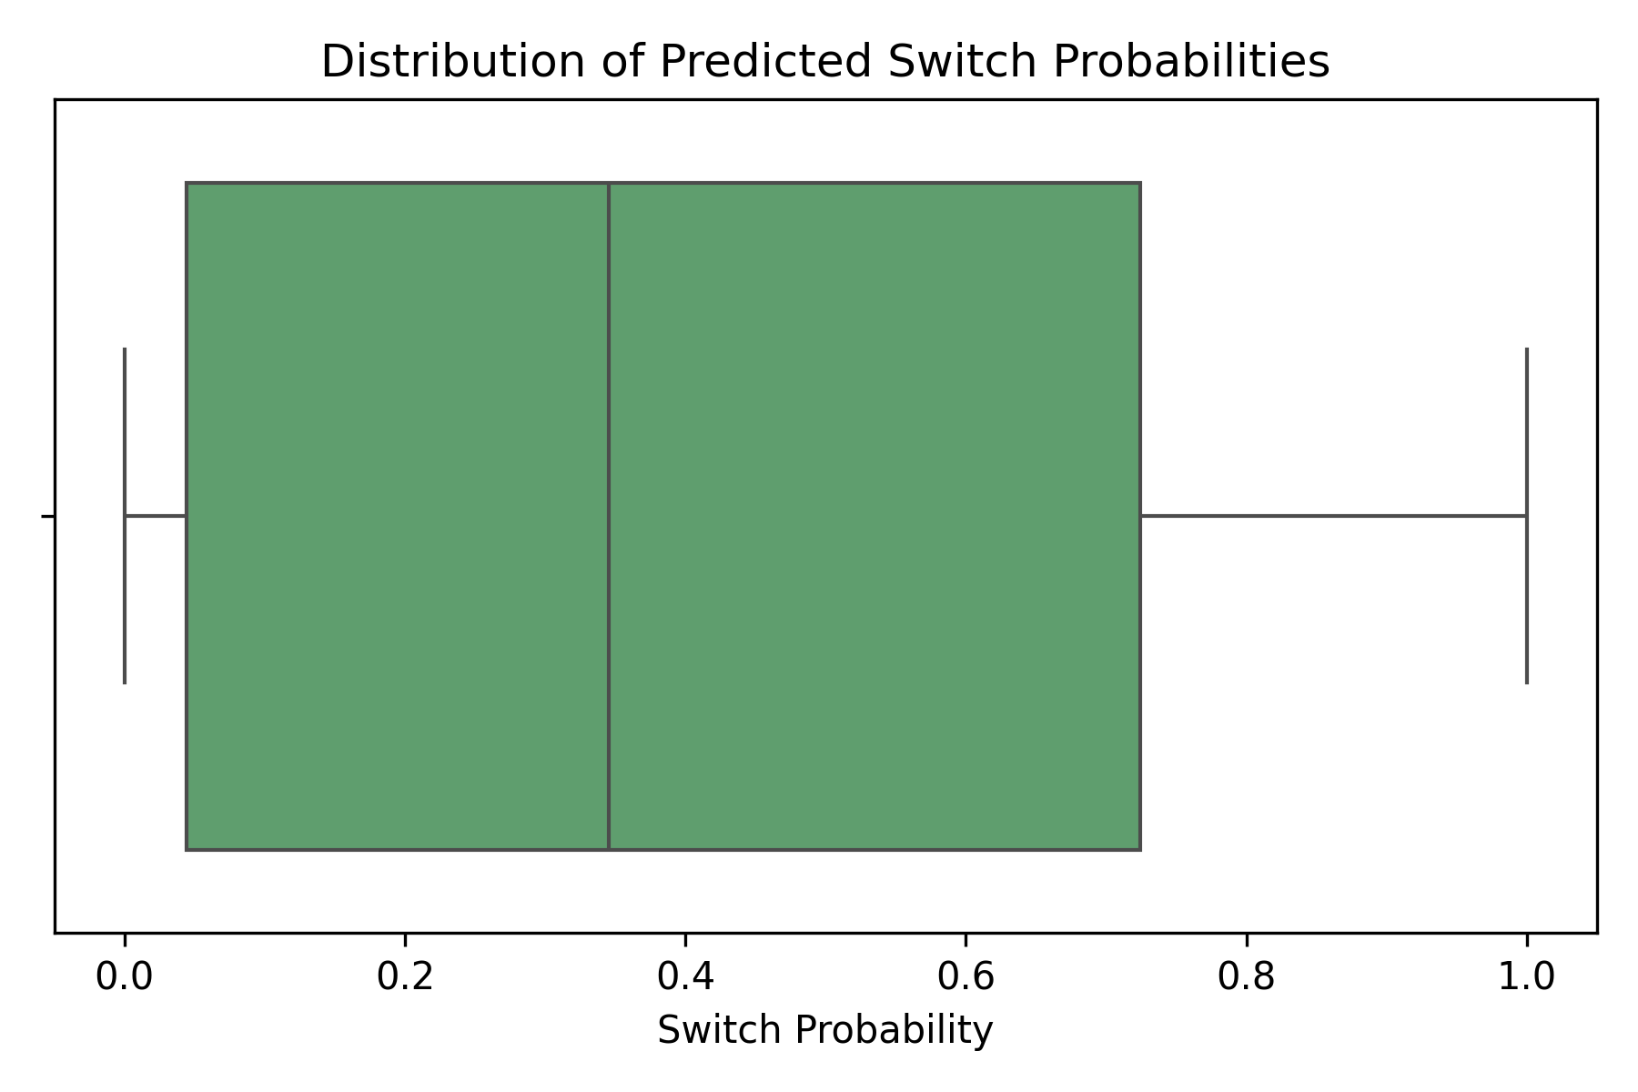
This boxplot shows the probability distribution of predicting a switch. 25% of our predictions lie at around 5% probability of a switch. Another 25% of our predictions are in a range of around 5% to 35% probability of a switch. Another 25% of our predictions are in a range of around 35% to 70%. The last 25% of our predictions are between 70% to 100% of a code switch. Our probabilities are skewed right, which indicates that we predict more no_switches than switches. This makes sense, as our dialogues have more no_switch instances than switch instances.
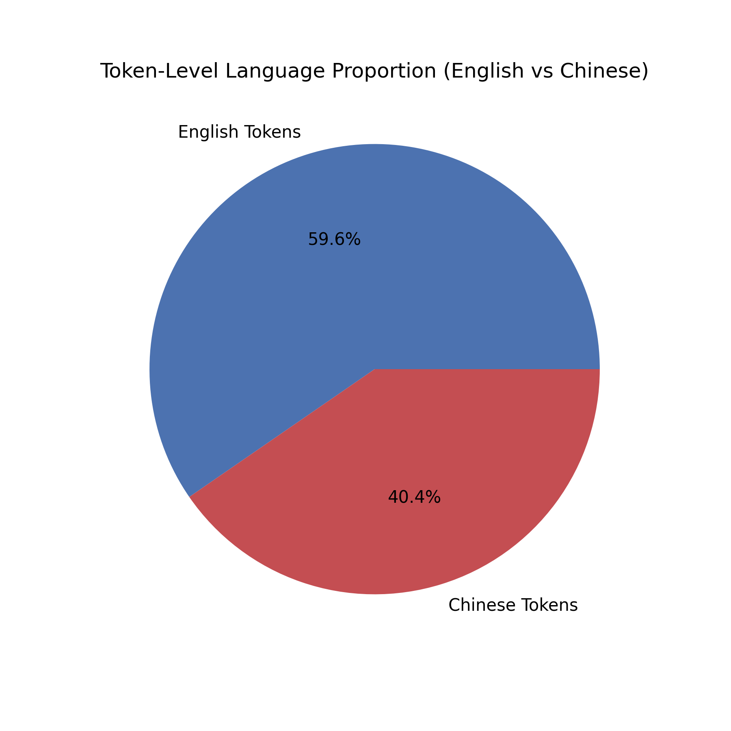
This pie chart demonstrates the balance of our tokens. Around 40% of our tokens are Mandarin characters, while 60% are English characters. This provides a balanced dataset that we can effectively use to develop our models.
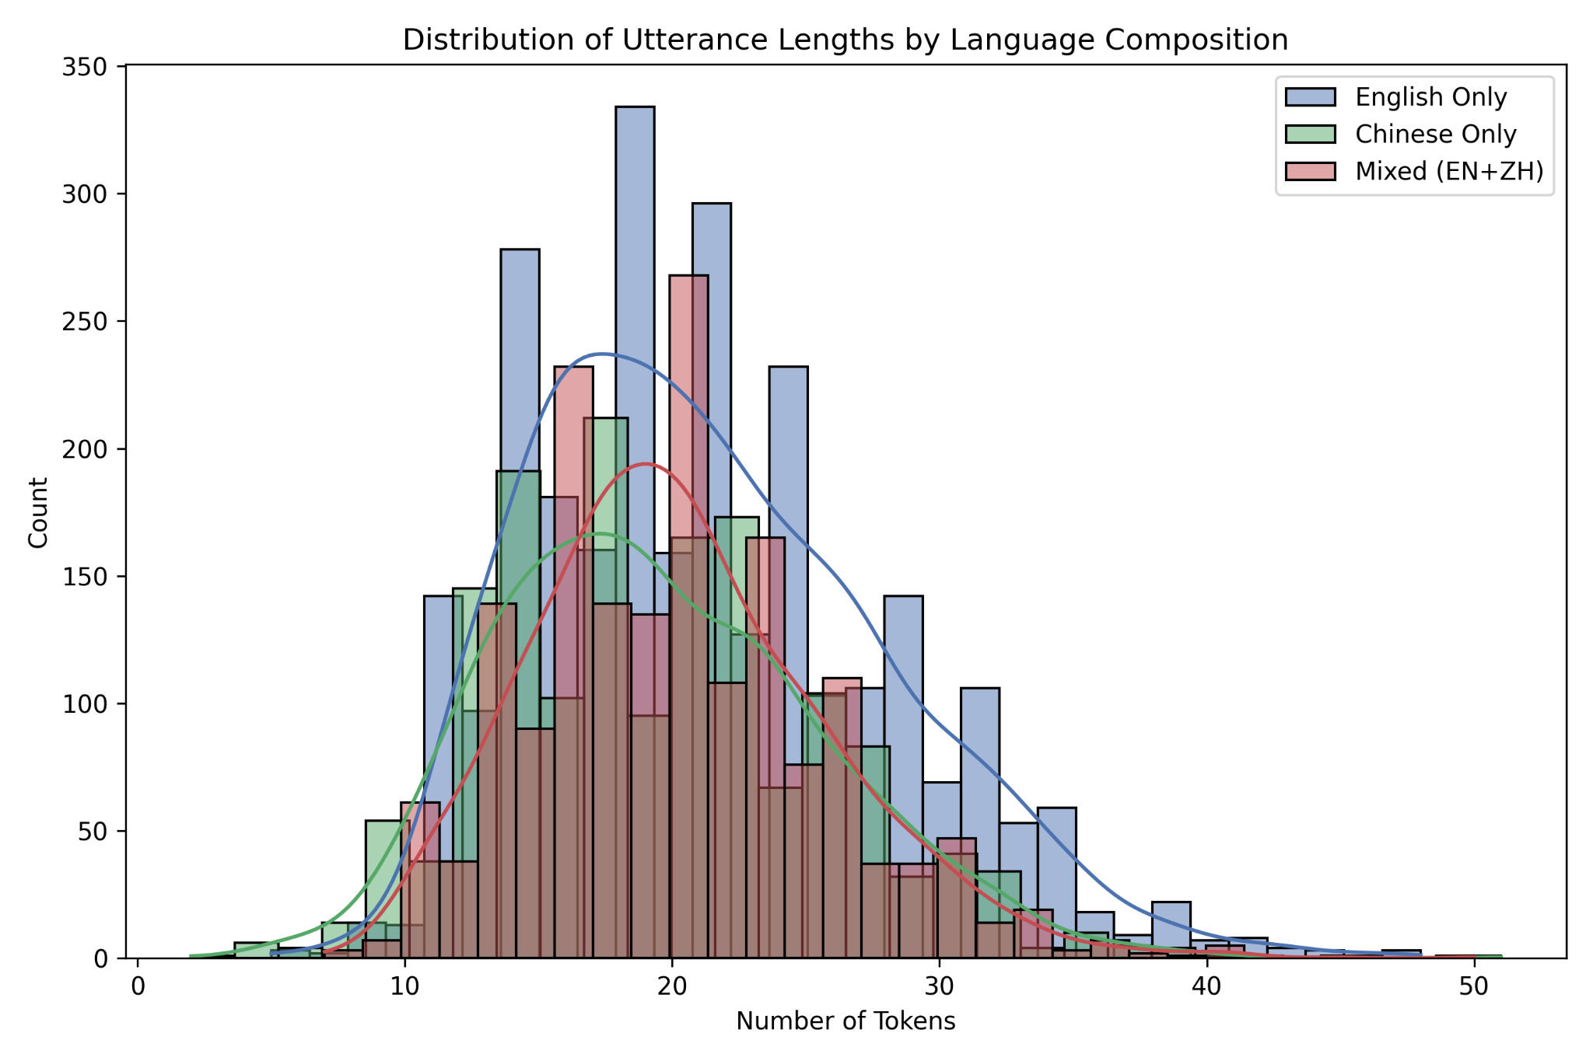
The graph shows that most utterances fall between 15 and 30 tokens, reflecting typical conversational or task-related exchanges. Shorter utterances (under ~10 tokens) likely represent quick acknowledgments or brief responses, such as “Sure” or “Okay.” Longer utterances (over ~30 tokens) are less common and likely correspond to more detailed explanations or multi-sentence descriptions, such as project updates or instructions. The difference in curve shapes also suggests that English utterances tend to be longer, Chinese utterances more compact, and mixed utterances fall in between.
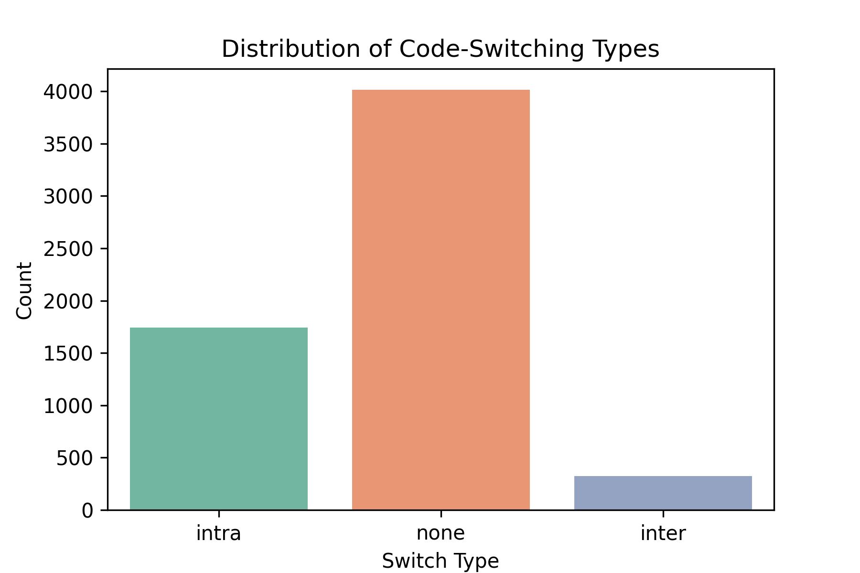
This histogram shows the count of each switch type (inter and intra-sentential) in our dataset. The dataset has more instances of intrasentential (within an utterance) than intersentential (between utterances). This makes sense, since code switching between English and Mandarin is primarily used to communicate technical terms like PR, bugs, commits, staging, etc. These technical terms appear within sentences, and usually aren’t at the start or end of a sentence.

Feature Engineering Strategy
1. Classical (Baseline) Numerical Feature Plan
We are currently using TF-IDF n-grams as our main feature representation. To expand this to include interpretable numerical features that can capture not only linguistic, but also contextual cues for code switching, some other features we can implement are:
- Current Token TF-IDF (1-3 grams)
  - Including weighted token frequencies up to the current position allows the model to learn which specific words and phrases commonly precede a switch event. Since code-switching can be triggered by certain linguistic constructions or borrowed expressions, this feature helps the model detect such precursors in the running text.
- Previous Token Language ID
  - The language identity of the preceding token (English, Mandarin, or other) is a crucial predictor, as code-switching patterns are heavily influenced by the language of the surrounding context. For instance, a switch is more likely to occur after a stretch of tokens in one language, especially at syntactic or semantic boundaries.
- Token Length
  - Token length provides a simple yet informative signal. English words typically contain multiple characters, whereas Mandarin tokens are often single or double characters. This difference can help the model discriminate between languages and identify mixed-language tokens or switch boundaries where character sets change.
- Proportion of English Tokens in Context
  - By tracking the running ratio of English tokens before the current position, the model can detect when one language begins to dominate the conversation. Switches often occur when there’s a shift in linguistic balance, such as transitioning from predominantly one language to another, making this feature useful for capturing global context.
- POS Tag of Previous Token
  - Part-of-speech tags can reveal syntactic cues related to switching. For example, switches frequently occur after function words like prepositions, conjunctions, or pronouns. Including the previous token’s POS tag helps the model anticipate likely switch points based on grammatical structure.
- Relative Token Index (Normalized position)
  - The normalized position of a token within an utterance can indicate structural tendencies of code-switching. Prior research shows that switches often cluster in mid-sentence (intrasentential) regions rather than at the very beginning or end, so encoding positional information allows the model to learn such tendencies.
- Presence of Trigger Words
  - Certain words (especially domain-specific or technical terms) act as triggers for language switching. For example, English words like “merge” or “deploy” may be inserted into predominantly Mandarin discourse. Including a binary indicator for the presence of these trigger words in preceding tokens helps the model capture semantic triggers for switching.
- Character Set Ratio in Token
  - By quantifying the ratio of character types (Latin letters vs. Han characters), this feature captures hybrid tokens or transitions within a single token, which are often strong indicators of code-switching behavior. Collectively, these features create a richer vector representation per token, enabling classical models to learn more diverse and interpretable linguistic patterns.
2. Deep Learning Feature Plan
Beyond logistic regression and random forest, we can let our model train on higher-level contextual relationships instead of manually handcrafting features. Since our dataset is already tokenized and labelled at every token, we can implement a sequence model with new features:
- Pre-trained Word Embeddings (Word2Vec / FastText for bilingual dataset)
  - Using bilingual embeddings allows semantically similar English and Mandarin words to occupy nearby regions in vector space. This helps the model identify conceptual or topical continuity across languages—an important cue for predicting when a speaker might switch.
- Character Level Embedding (BiLSTM over characters)
  - By encoding character-level information, the model can learn orthographic distinctions between scripts. This enables it to generalize to unseen or mixed tokens that may not appear in the training vocabulary, improving robustness in real-world multilingual data.
- Contextual Embedding (Multilingual BERT)
  - Contextual embeddings derived from multilingual BERT allow each token representation to be informed by its surrounding words in both directions. This captures nuanced contextual relationships (semantic shifts, discourse patterns, and syntactic dependencies) that precede switches more effectively than static embeddings.
- Speaker / Dialogue Turn
  - In conversational settings, switches often align with changes in speaker or dialogue turns. By including speaker or turn-level information, the model can learn patterns of inter- vs. intra-speaker code-switching, adding a layer of sociolinguistic context to the prediction process.
3. Justification and Roadmap
The baseline of TF-IDF with logistic regression and random forest models generates a solid F1-score for switch prediction. However, to enhance these models, we can implement richer features, such as token length, token position, and previous language, while experimenting with new models like SVM to assess their predictive power. In the deep learning phase, these manual features will be replaced with embedding-based representations, leveraging LSTM networks or Transformer-based token classifiers, such as mBERT models. This progression is effective because it starts with interpretable features, allowing for insight into the model’s behavior, and gradually moves toward learned representations, which enhance generalization and are better suited for scaling to larger, more complex datasets.

Initial Model Strategy & Baseline Results
To establish an initial benchmark for predicting token-level language switches, two classical machine learning models were evaluated: Logistic Regression (LogReg) and Random Forest (RF). Both models were trained on token-level context features extracted from the dataset, with the task being to predict whether a language switch occurs between consecutive tokens.
Model | Accuracy | Precision | Recall | F1-score | ROC-AUC
Logistic Regression | 0.711 | 0.583 | 0.766 | 0.662 | 0.795
Random Forest | 0.763 | 0.649 | 0.778 | 0.708 | 0.831
Logistic Regression Class Wise
Model | Precision | Recall | F1-score | Support
No Switch | 0.83 | 0.68 | 0.75 | 15000
Switch | 0.58 | 0.77 | 0.66 | 8793
Random Forest Class Wise
Model | Precision | Recall | F1-score | Support
No Switch | 0.85 | 0.75 | 0.80 | 15000
Switch | 0.65 | 0.78 | 0.71 | 8793
Both models show respectable overall accuracy, with the Random Forest clearly outperforming Logistic Regression, achieving a higher ROC-AUC (0.831) and improved F1-score (0.708). This confirms that token-level context contains learnable linguistic signals for code-switching prediction. For the minority “switch” class, the F1-score is the most meaningful indicator, as it balances precision (avoiding false positives or predicting a switch when none occurs) and recall (correctly identifying true switches).
Logistic Regression captures many switches (recall = 0.766) but suffers from lower precision (0.583), suggesting that linear decision boundaries are insufficient for capturing subtle contextual triggers.
Random Forest improves both precision (0.649) and recall (0.778), demonstrating that non-linear interactions between tokens are important for detecting code-switch points.
Despite the improvement, the F1-scores indicate that both models struggle with fine-grained contextual cues, such as syntactic boundaries, discourse-level context, and cultural or lexical markers. This suggests that bag-of-words or simple token-level features alone cannot fully capture the nuances of code-switching behavior. One important facet to notice is that when considering dialogue, it is always important to look at context. By assigning a weight to every token that comes before a prediction index, we can consider the weighted importance of every previous token, which can improve our predictive power.
Future Modeling Strategy
Given the baseline performance and the sequential nature of the task, the next step is to implement sequence-based deep learning models, such as a Bidirectional LSTM (BiLSTM) or a small Transformer encoder. A BiLSTM with token embeddings derived from sources like FastText or multilingual BERT is well-suited for the problem because it captures sequential dependencies across tokens, unlike bag-of-words or TF-IDF representations. Additionally, it learns shared semantic representations for both English and Mandarin tokens, enabling the model to identify nuanced linguistic cues that precede or follow code-switching events, like sentence structure, topic shifts, or the use of function words. The expected gains include higher recall for the minority “switch” class due to improved temporal modeling, as well as an overall increase in F1-score, likely surpassing 0.85 for switch prediction. Furthermore, this approach promises more interpretable insights into the linguistic and contextual conditions that drive code-switching behavior.

